Educational Album

of

Moola Suryaprakash Reddy



Dedicated to my Parents and Grand Parents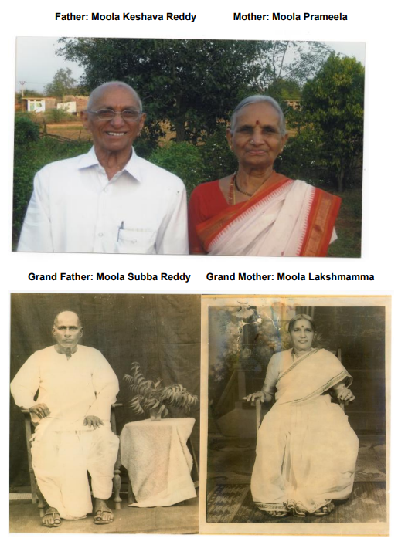

*“No man succeeds without a good woman behind him. Wife or mother, if it is both, he is twice blessed indeed.”*

Dedicated to My Beloved Wife Who is Champion of the House, Grand Children, and

All Family Members.

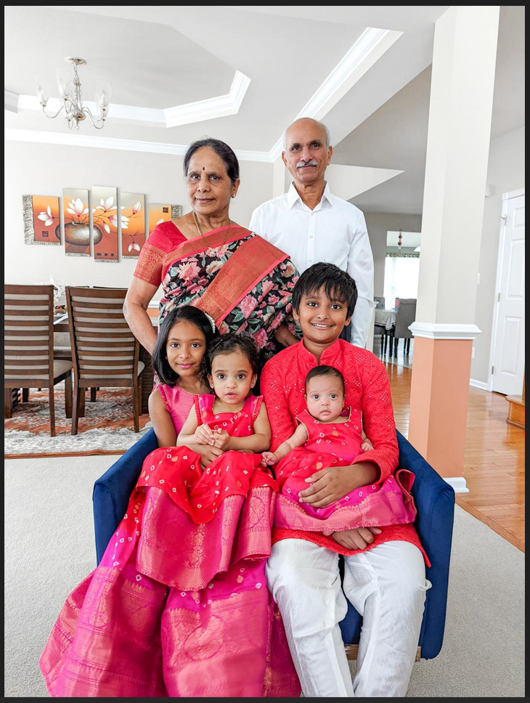

Moola Suryaprakash Reddy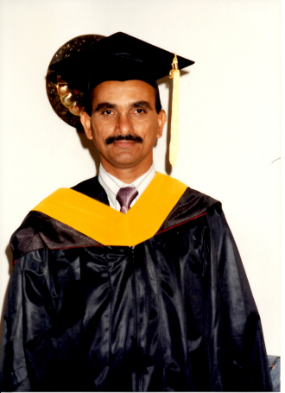

(Alabama A & M University, Graduated in 1995)

**Contents**

**1 College Degrees**

1.1 Master’s in Applied Data Science . . . . . . . . . . . . . . . . . . . . . . . . . . . . . . 11

1.2 Master’s in IT Project Management . . . . . . . . . . . . . . . . . . . . . . . . . . . . 12

1.3 Associate’s Citation in IT Project Management . . . . . . . . . . . . . . . . . . . . 13

1.4 Master’s in Computer Science. . . . . . . . . . . . . . . . . . . . . . . . . . . . . . . . . 14

1.5 Master’s in Education . . . . . . . . . . . . . . . . . . . . . . . . . . . . . . . . . . . . . . . 15

1.6 Bachelor’s in Education . . . . . . . . . . . . . . . . . . . . . . . . . . . . . . . . . . . . . 16

1.7 Master’s in Mathematics. . . . . . . . . . . . . . . . . . . . . . . . . . . . . . . . . . . . . 17

1.8 M S Rank Certificate in Mathematics. . . . . . . . . . . . . . . . . . . . . . . . . . . . . . . 18

1.9 Bachelor’s in Arts (Mathematics and Economics - I & II) . . . . . . . . . . . . 19

**2 Teacher Certification**

2.1 Ohio State High School Mathematics Teacher Certification . . . . . . . . . . 20

**3. Coursera Certifications**

3.1 University of Michigan

3.1.1 Python for Everybody. . . . . . . . . . . . . . . . . . . . . . . . . . . . . . . . . . . . . 22

3.1.2 Programming for Everybody Using Python. . . . . . . . . . . . . . . . . . . . . 22

3.1.3 Python Data Structure. . . . . . . . . . . . . . . . . . . . . . . . . . . . . . . . . . . . . 23

3.1.4 Using Databases with Python. . . . . . . . . . . . . . . . . . . . . . . . . . . . . . . . 23

3.1.5 Using Python to Access Web Data. . . . . . . . . . . . . . . . . . . . . . . . . . . 24

3.1.6 Capstone: Retrieving, Processing, and

Visualizing Data with Python. . . . . . . . . . . . . . . . . . . . . . . . . . . . . . . . 24

3.1.7 A Crash Course in Data Science. . . . . . . . . . . . . . . . . . . . . . . . . . . . . 25

3.1.8 Watching Three TED Talks Videos . . . . . . . . . . . . . . . . . . . . . . . . . . . 25

3.1.9 Introduction to Data Science in Python. . . . . . . . . . . . . . . . . . . . . . . . 25

3.1.10 Applied Machine Learning in Python. . . . . . . . . . . . . . . . . . . . . . . . . 26

3.1.11 Applied Text Mining in Python. . . . . . . . . . . . . . . . . . . . . . . . . . . . . . 26

3.1.12 Applied Social Network Analysis in Python. . . . . . . . . . . . . . . . . . . . 27

3.1.13 Applied Plotting, Charting, & Data

Representation in Python. . . . . . . . . . . . . . . . . . . . . . . . . . . . . . . . . . 27

3.1.14 PostgreSQL for Everybody. . . . . . . . . . . . . . . . . . . . . . . . . . . . . . . . 28

3.1.15 Database Design and Basic SQL in PostgreSQL. . . . . . . . . . . . . . . 28

3.1.16 Intermediate PostgreSQL. . . . . . . . . . . . . . . . . . . . . . . . . . . . . . . . . 29

3.1.17 JSON and Natural Language Processing in PostgreSQL. . . . . . . . . 29

3.1.18 Database Architecture Scale and NoSQL with Elasticsearch. . . . . . 30

3.1.19 Web Application for Everybody. . . . . . . . . . . . . . . . . . . . . . . . . . . . . 30

3.1.20 Building Web Application in PHP. . . . . . . . . . . . . . . . . . . . . . . . . . . 31

3.1.21 Introduction to Structured Query Language SQL. . . . . . . . . . . . . . 31

3.1.22 Building Database Application in PHP. . . . . . . . . . . . . . . . . . . . . . 32

3.1.23 Java Script, JQuery, and JSON. . . . . . . . . . . . . . . . . . . . . . . . . . . 32

3.2 International Business Machines (IBM) Corporation

3.2.1 IBM Cloud Essentials. . . . . . . . . . . . . . . . . . . . . . . . . . . . . . . . . . . 33

3.2.2 Introduction to Agile Development and Scrum. . . . . . . . . . . . . . . . 33

3.2.3 Introduction to Artificial Intelligence (AI) . . . . . . . . . . . . . . . . . . . . 34

3.2.4 Getting Started with AI using IBM Watson. . . . . . . . . . . . . . . . . . . 34

3.2.5 Building AI Powered Chatbots Without Programming . . . . . . . . . 35

3.2.6 Python for Data Science, AI & Development. . . . . . . . . . . . . . . . 35

3.2.7 Python Project for AI & Application Development. . . . . . . . . . . . 36

3.2.8 Introduction to Cloud Computing (AI) . . . . . . . . . . . . . . . . . . . . 36

3.2.9 Introduction to Web Development with HTML, CSS, JavaScript 37

3.2.10 Developing AI Application with Python and Flask. . . . . . . . . . . . 37

3.2.11 Getting Started with Git and GitHub. . . . . . . . . . . . . . . . . . . . . . . . 38

3.3 Coursera Project Network

3.3.1 Introduction to Github and Visual Studio Code . . . . . . . . . . . . . . . . 38

3.4 Amazon Web Services

3.4.1 AWS Addressing Security Risk. . . . . . . . . . . . . . . . . . . . . . . . . . . . . 39

3.4.2 Building Serverless Applications. . . . . . . . . . . . . . . . . . . . . . . . . . . . . 39

3.4.3 AWS Cloud Technical Essentials. . . . . . . . . . . . . . . . . . . . . . . . . . . 40

3.4.4 AWS Migrating to the Cloud. . . . . . . . . . . . . . . . . . . . . . . . . . . . . . . 40

3.5 Microsoft 365 Fundamentals

3.5.1 Microsoft 365 Fundamentals. . . . . . . . . . . . . . . . . . . . . . . . . . . . . 41

3.5.2 Work Smarter with Microsoft Word. . . . . . . . . . . . . . . . . . . . . . . . 41

3.5.3 Work Smarter with Microsoft Excel. . . . . . . . . . . . . . . . . . . . . . . . 42

3.5.4 Work Smarter with Microsoft PowerPoint. . . . . . . . . . . . . . . . . . . 42

3.6 Other Colleges / Companies

3.6.1 HTML, CSS, and Javascript for Web Developers - Johns Hopkins: 43

3.6.2 Single Page Web Application with AngularJS - Johns Hopkins: 43

3.6.3 Crash Course in Python (Google) . . . . . . . . . . . . . . . . . . . . . . . . . . . 44

3.6.4 Getting Started with Python (Google) . . . . . . . . . . . . . . . . . . . . .. . . 44

3.6.5 Duke: Python and Pandas for Data Engineering. . . . . . . . . . . . . . 45

3.6.6 Problem Solving, Python Programming, and Video Games . . . 45

3.6.7 Responsive Website Basics: Code with HTML,CSS, and JavaScript 46

3.6.8 Introduction to Web Development (University of California, Davis) 46

3.6.9 Endpoint and Systems (Windows, Unix, and Security (Cisco) . . . . 47

**4. Amazon Web Services (AWS) Training Certification**

4.1 Developing Serverless on AWS . . . . . . . . . . . . . . . . . . . . . . . . . . . . . . . . . . . 47

4.2 Running Containers on Amazon Elastic Kubernetes Services . . . . . . . . . . . . 48

4.3 Developing On AWS . . . . . . . . . . ….. . . . . . . . . . . . . . . . . . . . . . . . . . . . 48

4.4 AWS Technical Essentials . . . . . . . . . . . . . . . . . . . . . . . . . . . . . . . . . . . . . . 49

4.5 AWS Security Essentials . . . . . . . . . . . . . . . . . . . . . . . . . . . . . . . . . . . . . . . 49

**5. Commerce Learning Center Training Badges**

5.1 AWS Technical Essentials Part-1. . . . . . . . . . . . . . . . . . . . . . . . . . . . . . . . . . 50

5.2 AWS Technical Essentials Part-2 . . . . . . . . . . . . . . . . . . . . . . . . . . . . . . . . 50

5.3 2022: AWS Cloud & the Value Proposition. . . . . . . . . . . . . . . . . . . . . . . . . . . 51

5.4 AWS Cloud Economics . . . .. . . . . . . . . . . . . . . . . . . . . . . . . . . . . . . . . . . 51

5.5 AWS Cloud Architecture Desing, Principles . . . . . . . . . . . . . . . . . . . . . . . . . . 52

5.6 AWS Cloud Security & Compliance . . . . . . . . . . . . . . . . . . . . . . . . . . . . . . . 52

5.7 AWS Access Management. . . . . . . . . . . . . . . . . . . . . . . . . . . . . . . . . . . 53

5.8 AWS Cloud Deployment & Operation . . . . . . . . . . . . . . . . . . . . . . . . . . . . . . 53

5.9 Core AWS Services . . . . . . . . . . . . . . . . . . . . . . . . . . . . . . . . . . . . . . . . 54

5.10 AWS Technology Support Resources . . . . . . . . . . . . . . . . . . . . . . . . . . . . 54

5.11 AWS Bootcamp 2023: Session1 Replay(May 2023) . . . . . . . . . . . . . . . . . . . 55

5.12 AWS Bootcamp 2023: Session2 Replay(May 2023) . . . . . . . . . . . . . . . . . . . 55

5.13 2020: AWS Cloud & the Value Proposition . . . . . . . . . . . . . . . . . . . . . . . . . . . . 56

5.14 Creating a Basic Angular Application . . . . . . . . . . . . . . . . . . . . . . . . . . 56

5.15 Introduction to the PowerPoint 2016 Interface and Basic Tasks . . . . . . . . . 57

5.16 Perl Programming Techniques . . . .. . . . . . . . . . . . . . . . . . . . . . . . . . . 57

5.17 Oracle Database 12c Introduction to SQL: SQL*Plus and SELECT Statement 58

5.19 An Introduction to Basic Cloud Concepts . . . . . . . . . . . . . . . . . . . . . . . . . . 58

5.20 Cloud Computing Fundamentals: Overview . . . . . . . . . . . . . . . . . . . . . . . . 59

5.21 Oracle ADF 1 , , , , , , , ,, , , , , . . . .. . . . . . . . . . . . . . . . . . . . . . . . . . . 59

5.22 Object-Orient Analysis and Design Using UML: Hands-On . . . . . . . . . . . . . 60

5.23 Java Web Applications: Hands-On . . . . . . . . . . . . . . . . . . . . . . . . . . . . . 60

5.24 Creating Basic Presentations using PowerPoint 2003 . . . . . . . . . . . . . . . . . 61

6. SAS Online Tutor

6.1 SAS Online Tutor: Basic and Intermediate SAS. . . . . . . . . . . . . . . . . .. . . . . . 61

7. Oracle University

7.1 Oracle Reports Developer 10g: Build Reports. . . . . . . . . . . . . . . . . . . . . . . 62

8. Brainbench and tekmetrics Training Certification

8.1 ColdFusion 4.5 Programmer. . . . . . . . . . . . . . . . . . . . . . . . . . . . . . . . . . . . . 62

8.2 COBOL II Programmer . . . . . . . . . . . . . . . . . . . . . . . . . . . . . . . . . . . . . . . . . 63

8.3 Active Server Pages Programmer. . . . . . . . . . . . . . . . . . . . . . . . . . . . . . . . . 63

8.4 Oracle Developer 2000 Programmer. . . . . . . . . . . . . . . . . . . . . . . . . . . . . . . 64

8.5 C Programmer. . . . . . . . . . . . . . . . . . . . . . . . . . . . . . . . . . . . . . . . . . . . . . . . 65

8.6 Web Programmer . . . . . . . . . . . . . . . . . . . . . . . . . . . . . . . . . . . .. . . . . . . . . . 66

8.7 MS Access Programmer. . . . . . . . . . . . . . . . . . . . . . . . . . . . . . . . . . . . . . . . 67

8.8 MS SQL Server Programmer. . . . . . . . . . . . . . . . . . . . . . . . . . . . . . . . . . . . . 68

8.9 HTML Programmer. . . . . . . . . . . . . . . . . . . . . . . . . . . . . . . . . . . . . . . . . . . . . 69

8.10 JavaScript Programmer. . . . . . . . . . . . . . . . . . . . . . . . . . . . . . . . . . . . . . . . 70

8.11 Visual Basic Programmer. . . . . . . . . . . . . . . . . . . . . . . . . . . . . . . . . . . . . . . 71

8.12 Oracle Programmer. . . . . . . . . . . . . . . . . . . . . . . . . . . . . .. . . . . . . . . . . . . . . 72

9.1 Financial / Accounting

9.1 Principles of Financial Accounting. . . . . . . . . . . . . . . . . . . . . . . . . . 73

9.2 ADP Accounting Connect Certification. . . . . . . . . . . . . . . . . . . . . . . 73

9.3 Accounting Professional Certificate. . . . . . . . . . . . . . . . . . . . . . . . . 74

9.4 Bookkeeping Basics. . . . . . . . . . . . . . . . . . . . . . . . . . . . . . . . . . . . 74

9.5 Assets in Accounting. . . . . . . . . . . . . . . . . . . . . . . . . . . . . . . . . . . . 75

9.6 Liabilities and Equity in Accounting. . . . . . . . . . . . . . . . . . . . . . . . . . . . . 75

9.7 Financial Statement Analysis. . . . . . . . . . . . . . . . . . . . . . . . . . . . . . . . . . 76

**Master’s in Applied Data Science (Not Yet Awarded)**

|  |  |  |
| --- | --- | --- |
| **Courses Completed for Master’s in Applied Data Science** | | **Weeks** |
| **1** | **Programming for Everybody** | **7** |
| **2** | **Python Data Structures** | **7** |
| **3.** | **Using Databases with Python** | **5** |
| **4.** | **Using Python to Access Web Data** | **6** |
| **5.** | **Capstone: Retrieving, Processing, and Visualizing data with Python** | **4** |
| **6.** | **A Crash Course in Data Science** | **1** |
| **7.** | **Ted Talks:**   1. **The Surprising Habits of Original Thinkers:** [**https://www.ted.com/talks/adam_grant_the_surprising_habits_of_original_thinkers/transcript?language=en**](https://www.ted.com/talks/adam_grant_the_surprising_habits_of_original_thinkers/transcript?language=en) 2. **Coding a Better Government:** [**https://www.ted.com/talks/jennifer_pahlka_coding_a_better_government/transcript**](https://www.ted.com/talks/jennifer_pahlka_coding_a_better_government/transcript) 3. **How to Manage for Collective Creativity:** [**https://www.ted.com/talks/linda_hill_how_to_manage_for_collective_creativity?language=en**](https://www.ted.com/talks/linda_hill_how_to_manage_for_collective_creativity?language=en) | **1** |
| **8.** | **Introduction to Data science in Python** | **4** |
| **9.** | **Applied Machine Learning in Python** | **4** |
| **10.** | **Applied Text Mining in Python** | **4** |
| **11.** | **Applied Social Network Analysis in Python** | **4** |
| **12.** | **Applied Plotting, Charting & Data Representation in Python** | **4** |

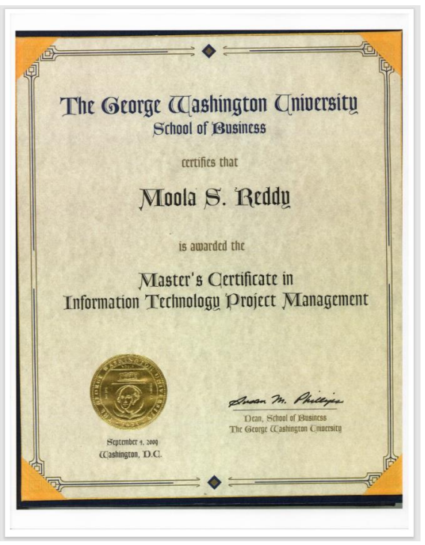

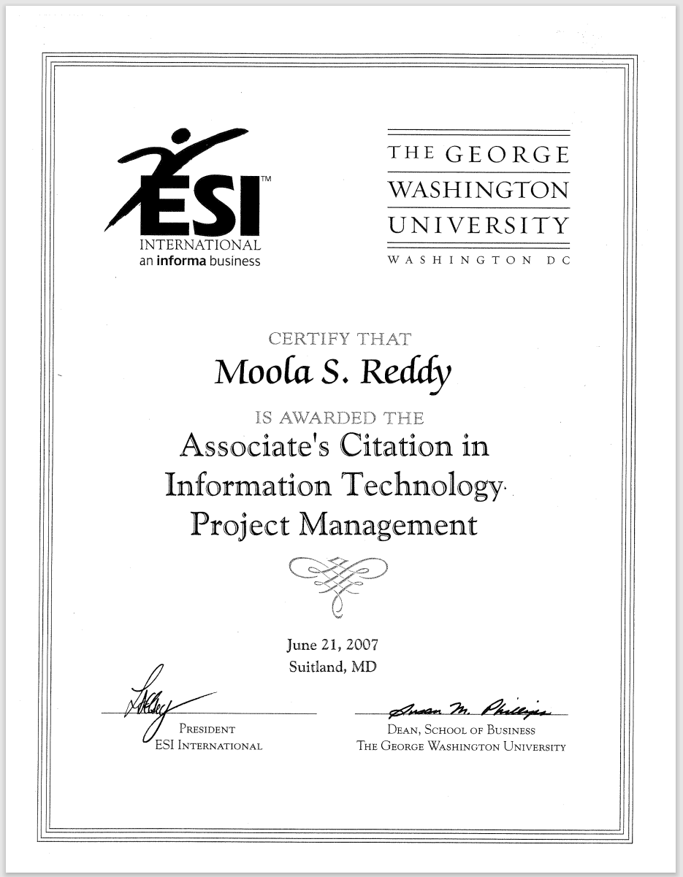



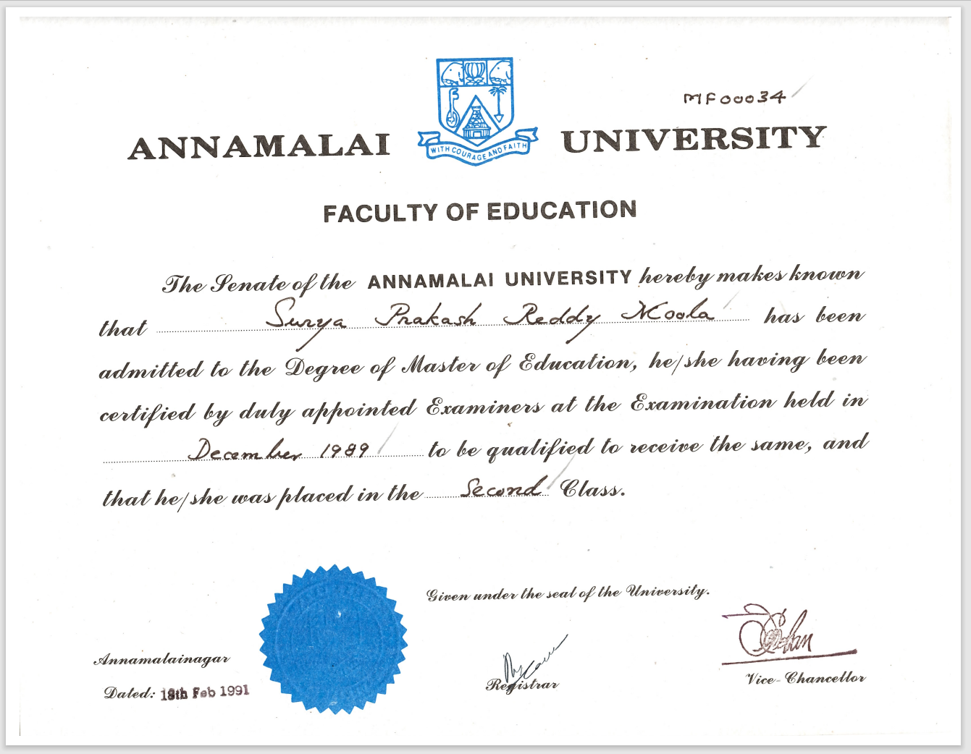

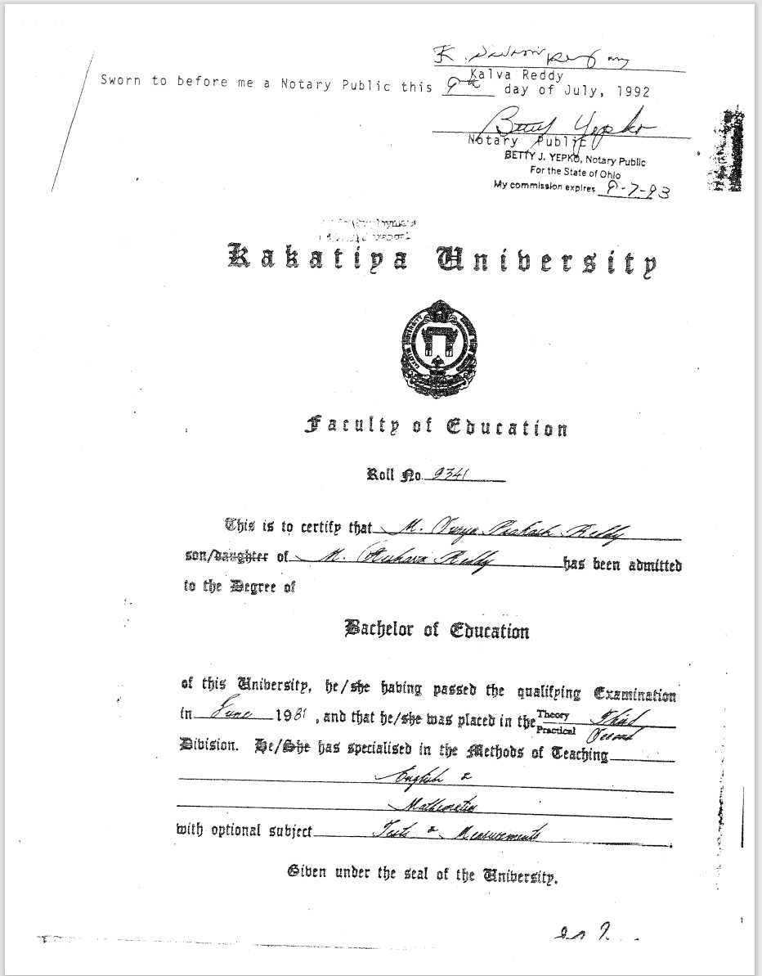

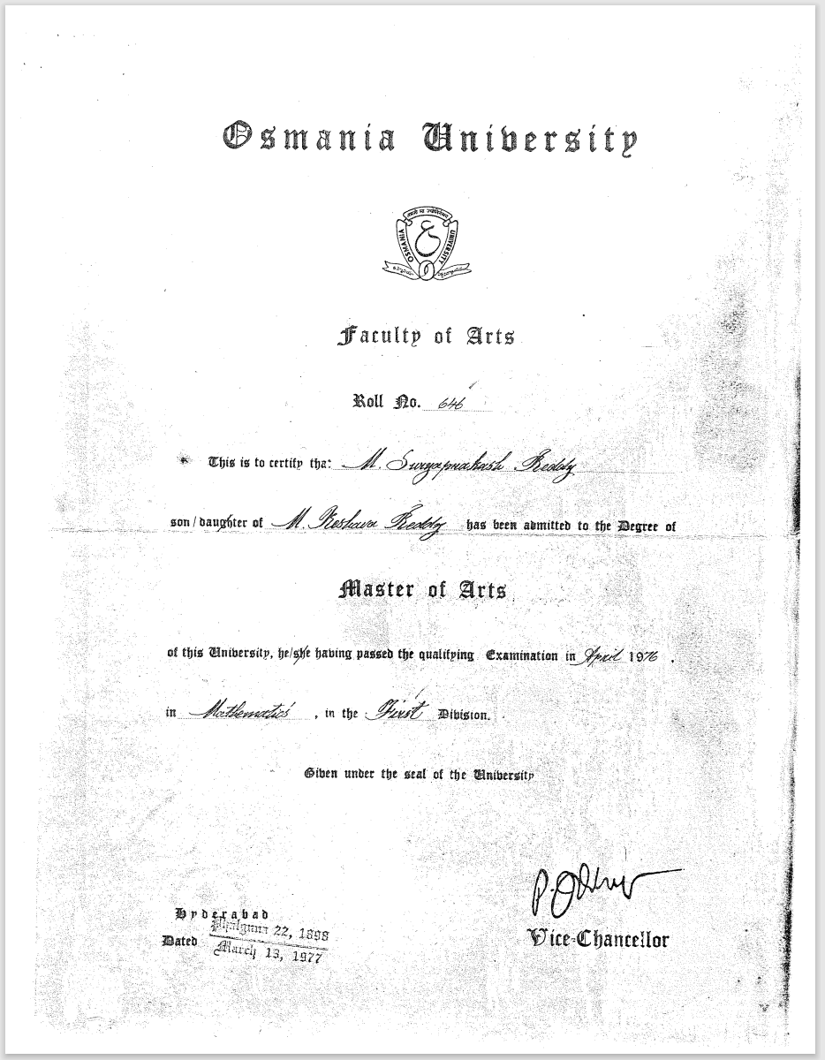

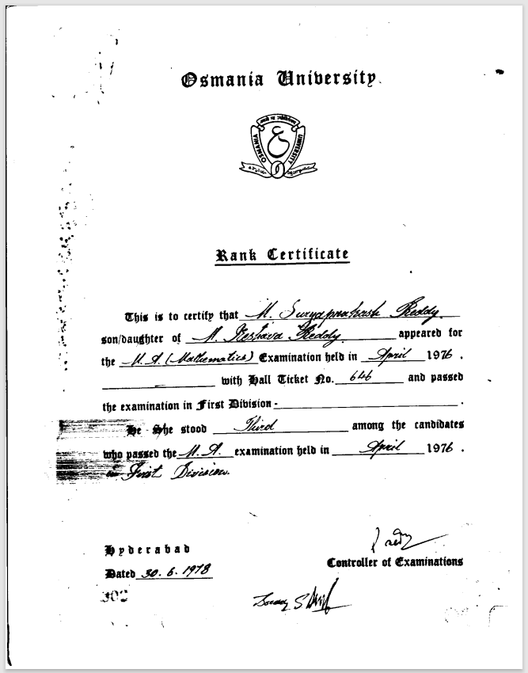

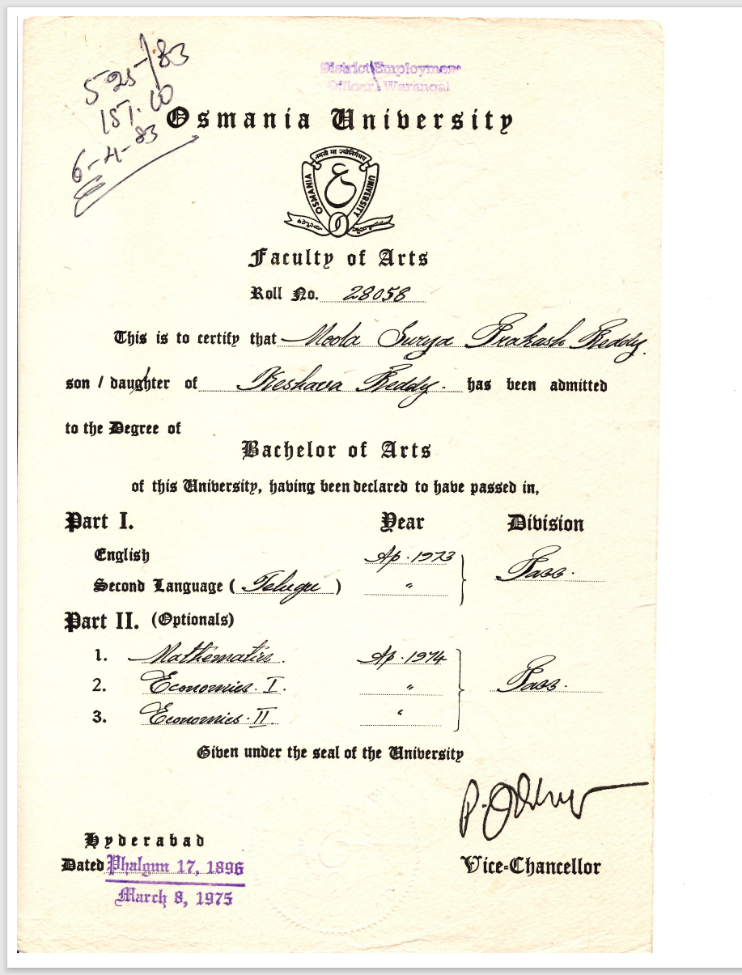

**Ohio State High-School Mathematics Teacher Certification**

**Exam name: National Teacher Examination (NTE)**

**Consists of 4 exams (2 hours each exam)**

1. **Test of General Knowledge (GK): (2 Hours Exam)**
2. **Literature and Fine Arts**
3. **Mathematics**
4. **Science**
5. **social Studies**
6. **Test of Communication Skills (CS): (2 Hours Exam)**
7. **Listening**
8. **Reading**
9. **Writing (Multiple-choice)**
10. **Writing an Essay**
11. **Test of Professional Knowledge (PK): (2 Hours Exam)**
12. **Planning instructions:**
13. **Implementing instructions**
14. **Managing instructions**
15. **Evaluating teaching/learning**
16. **Recognizing extra-classroom influences**
17. **Demonstrating Knowledge of professional behavior**
18. **Mathematics Test: (2 Hours Exam)**
19. **Basic (pre-college) Mathematics**
20. **Pre-calculus College Mathematics**
21. **Upper-division Mathematics**
22. **Professional Understanding and Pedagogy**



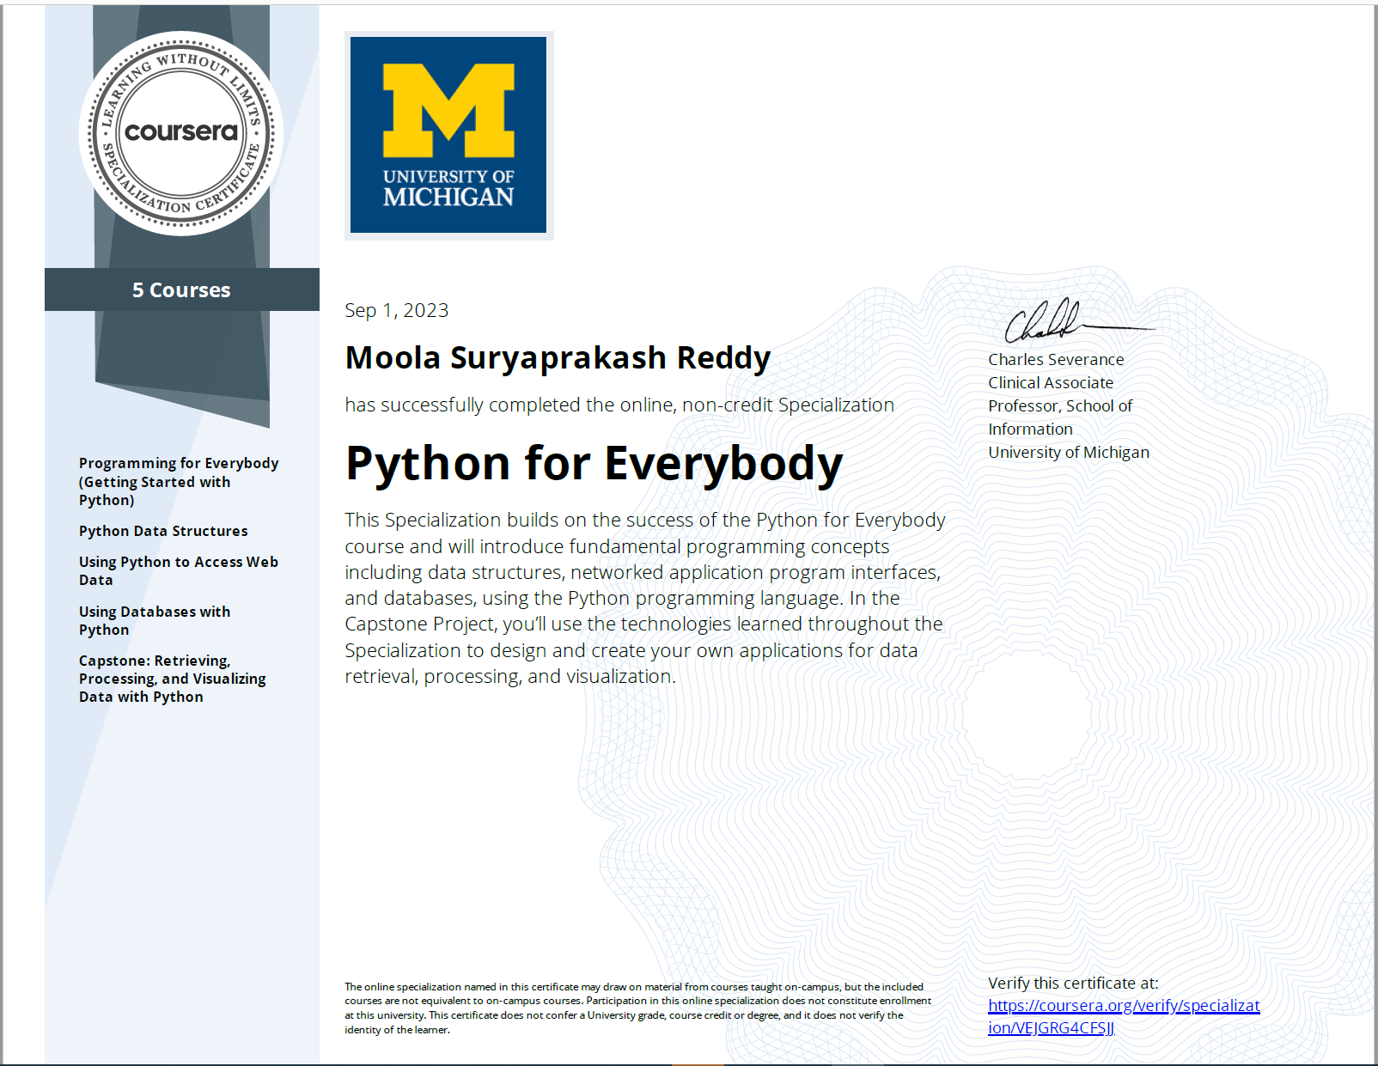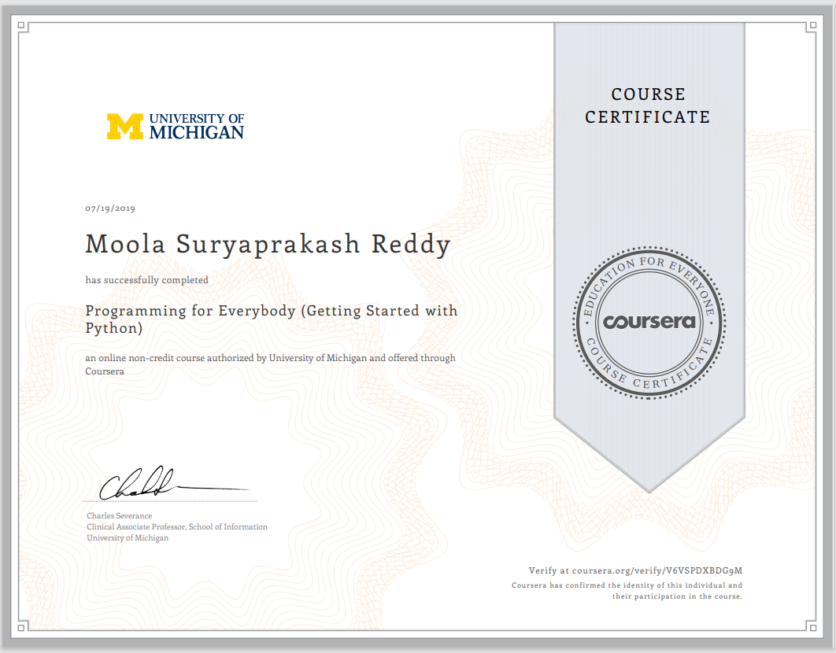

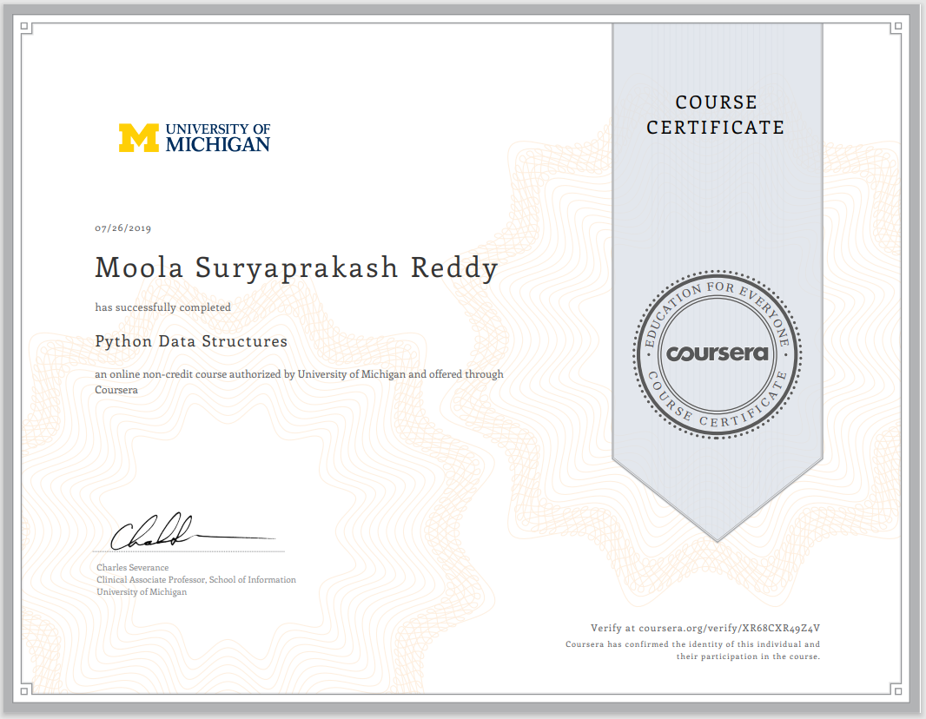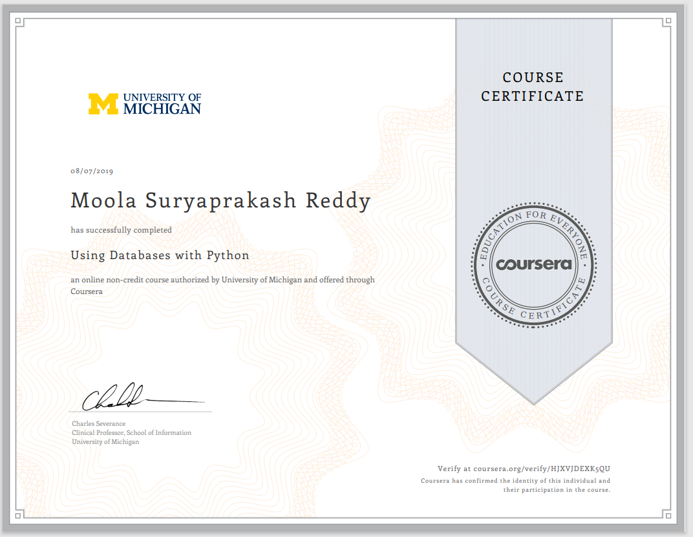

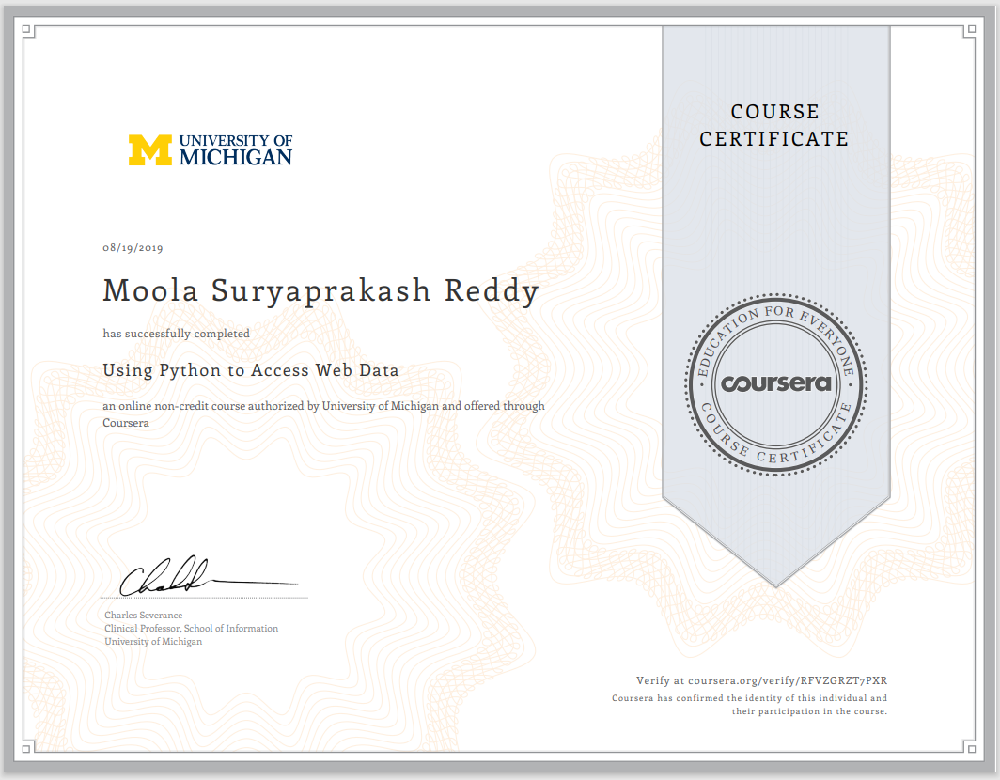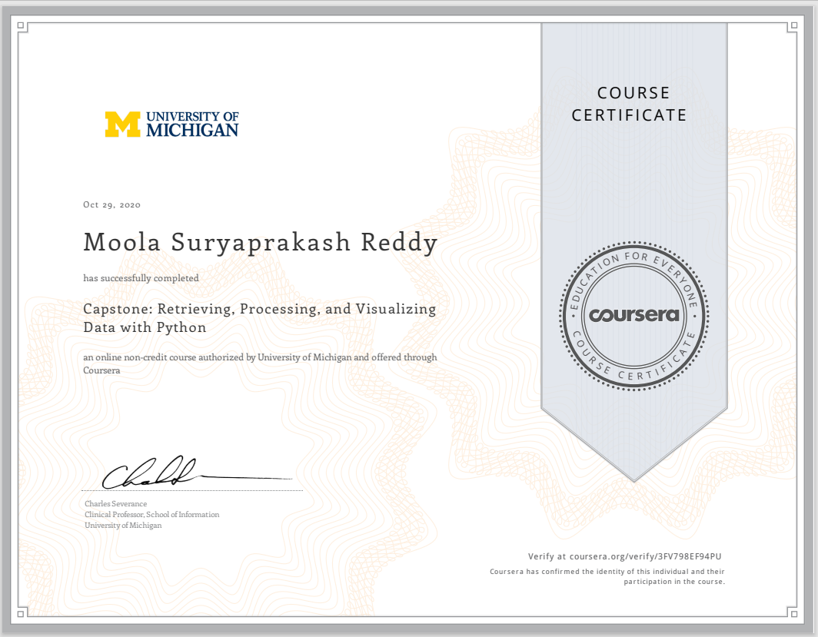

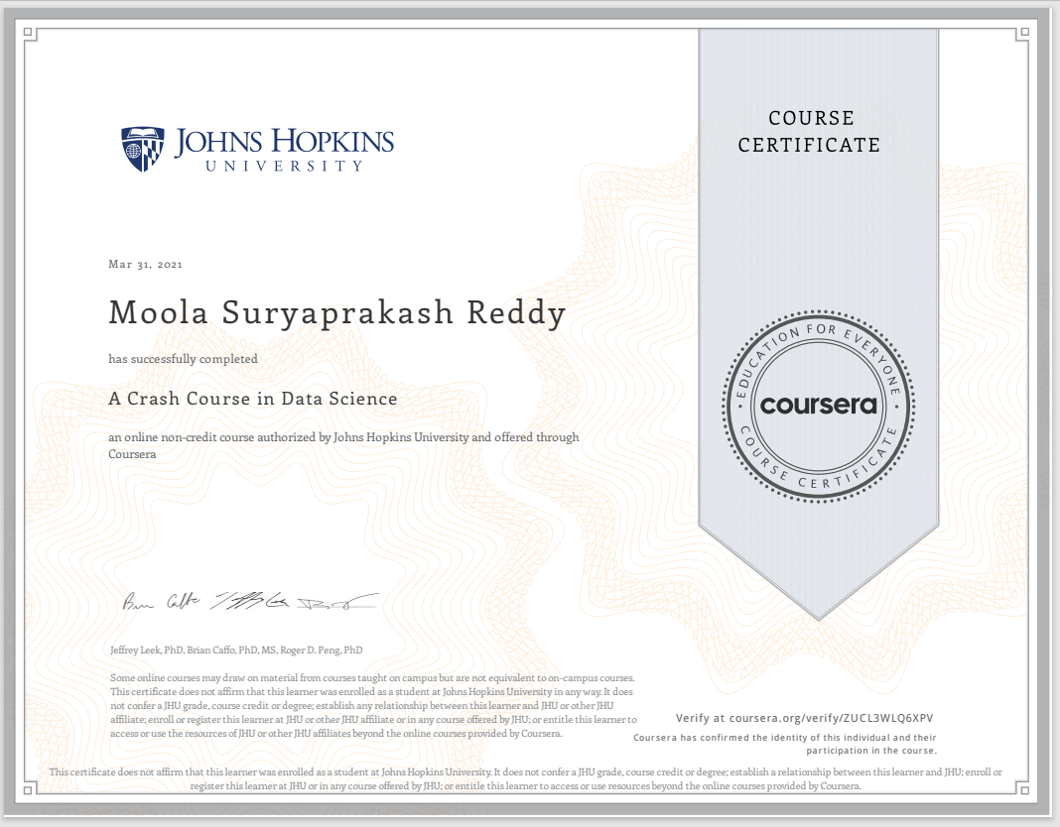

Ted Talks:

1. The Surprising Habits of Original Thinkers: <https://www.ted.com/talks/adam_grant_the_surprising_habits_of_original_thinkers/transcript?language=en>
2. Coding a Better Government: <https://www.ted.com/talks/jennifer_pahlka_coding_a_better_government/transcript>
3. How to Manage for Collective Creativity: <https://www.ted.com/talks/linda_hill_how_to_manage_for_collective_creativity?language=en>

